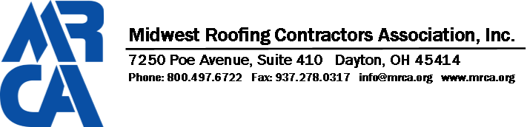
MRCA FOUNDATION CONTRIBUTION FORM
The purpose of the MRCA Foundation is to raise awareness and improve the industry by supporting educational programming, industry research, and industry-related academic scholarships. Your ongoing support of the MRCA Foundation is critical to sustaining this important mission.
Yes, I can help! I would like to support the mission of the Foundation! Please accept my MONTHLY contribution of:

❒ $100  $75  $50  $25  Other
for months Please begin my donation on this date:
Please accept my one-time contribution of:
❒ $10,000  $5000  $2500  $1000  Other

Donor Information:
Donor Name: Company Name: Address: _

City:
State:
Zip Code:

Phone: Email:

Payment:
❒ I have enclosed a check made payable MRCA Foundation
❒ Please send me an invoice for the amount indicated above
Please charge my credit card:  One time as indicated above  Monthly as indicated above
I would like to designate my contribution to the following area(s):
❒ Research  Education  Scholarship  CERTA

Credit Card Number Card Holders Name
Expiration Date Billing Zip Code

The MRCA Foundation is a charitable, nonprofit 501 (c)(3) organization (Federal Tax ID: 43-1495286) Contributions are tax-deductible as charitable contributions to the extent permitted by law.

Please return to: The MRCA Foundation, 7250 Poe Ave., Suite 410, Dayton, Ohio 45414 or email to: mmiller@mrca.org. Questions? Call Megan Miller at 800-497-6722.

